**Margaret Olley Art Trust Collection Room Residency**

**Artist in Residence Written Reflection**

Victoria Reichelt

2025

I was invited to undertake a residency at the Rockhampton Museum of Art as a part of the Flying Arts Mervyn Moriarty Landscape Award that I was awarded in 2024 for the work Focus 4.

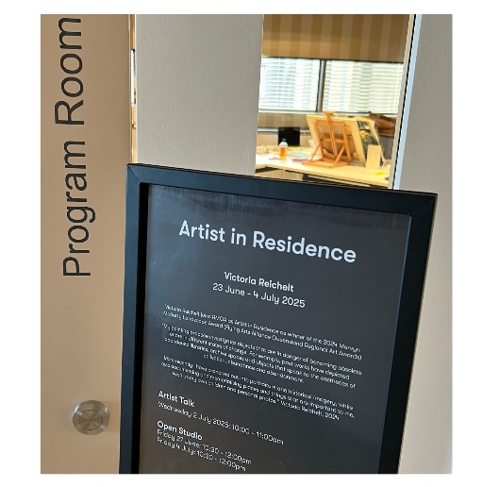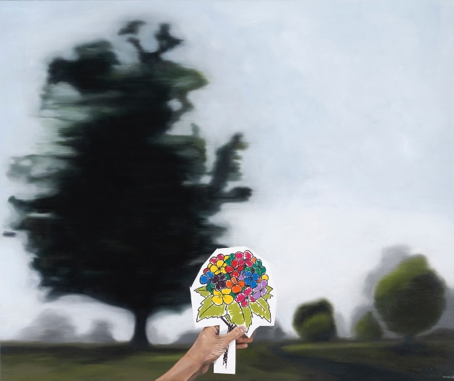

From the moment I arrived at the RMOA I was welcomed and made to feel part of the team. Helen Kavanagh did a wonderful job showing me around and introducing me to the staff. I was given a large area to paint in which is about ten times the size of the area I normally paint in at home.

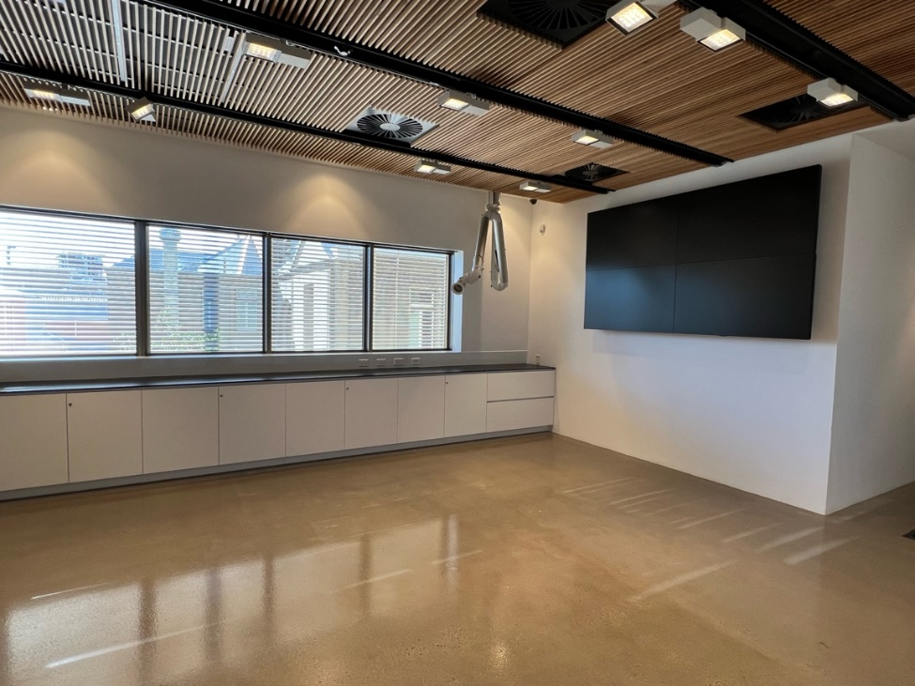

I was working on paintings of children’s cakes that I am making for an exhibition for the Jan Murphy Gallery (Brisbane) in 2026, so I brought the three works I am currently painting, along with the images that I will be working on for the next works in the series. These works act as little vignettes of parenting showing the joy and the trials of raising children.

Bringing the works in various different states of production gave visitors an insight into my process – seeing the works at all difference stages, including those yet to be drawn up, shows people how the works come together and perhaps also demystifies what can be an intimidating process (oil painting).

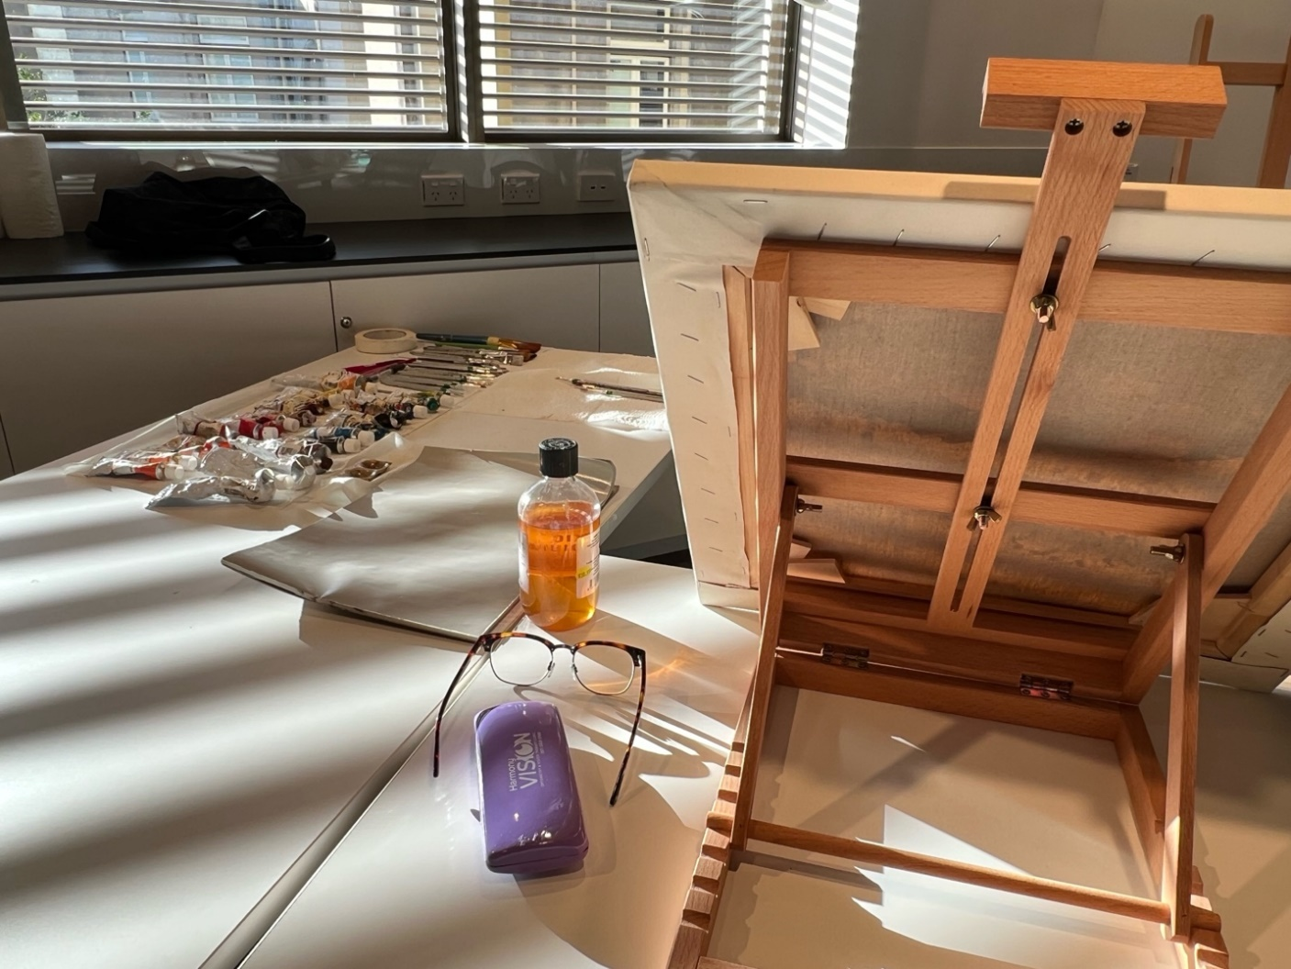

The work I was primarily working on was a cake that had numerous multi coloured sprinkles on it. I loved going into the gallery each day and the RMOA staff popping their heads in to see how the sprinkles were coming along.

In the first week I had a delightful visit from some local school children who had many questions to ask about the process but mainly the lollies on the cakes. They were a joy to chat to.

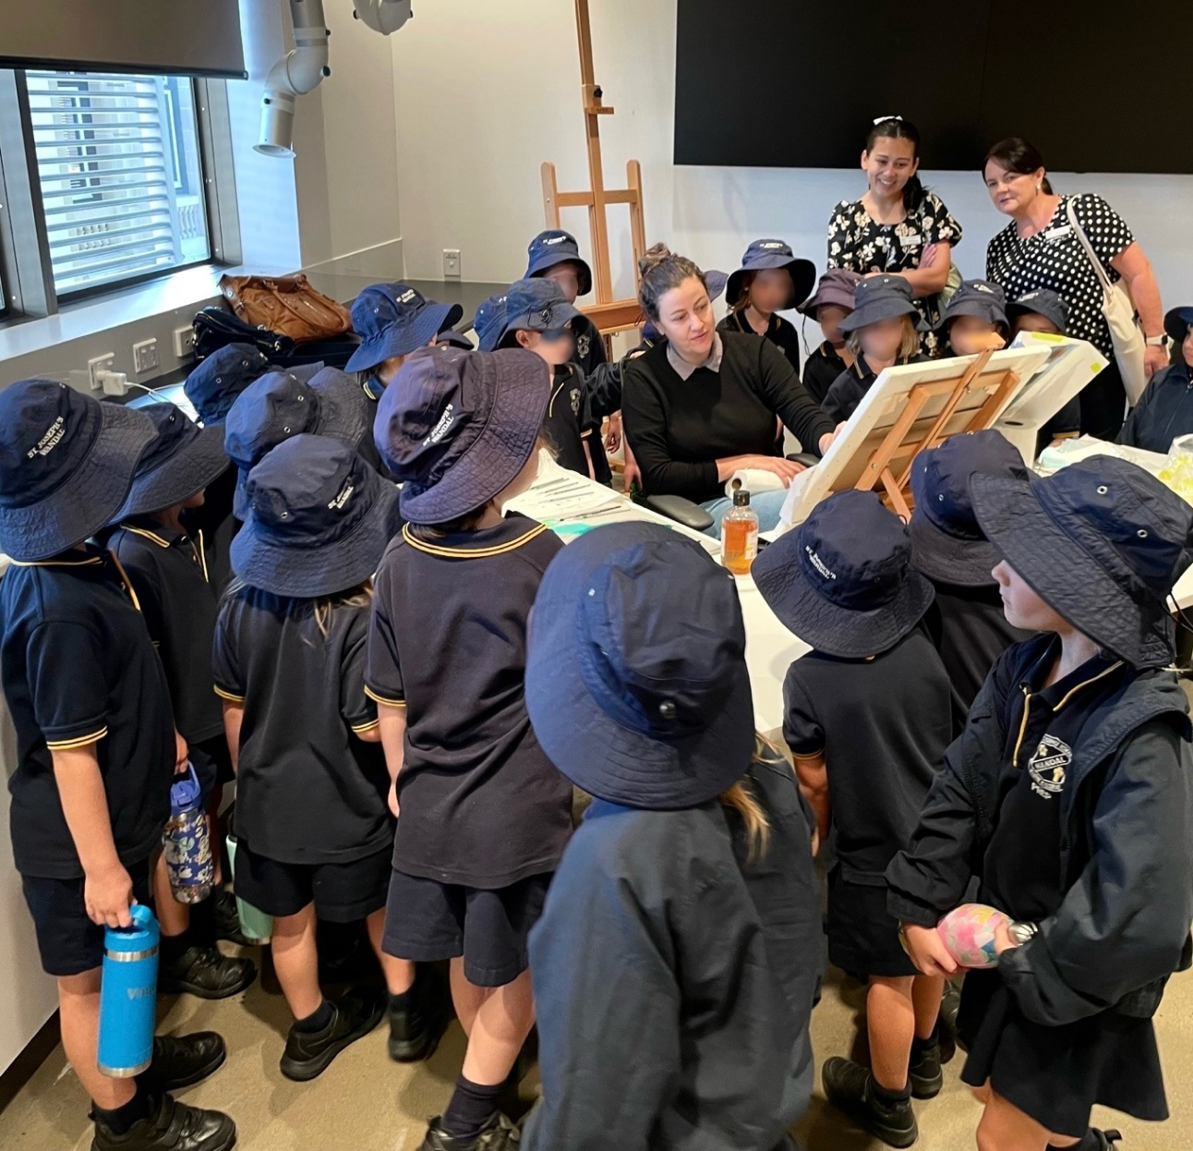

I undertook two open studios and had a number of visitors who wanted to know about the work and chat about art and painting. These were (hopefully) valuable for the visitors, but were very valuable to me as the people I met had some great feedback and interesting stories around children’s cakes, childhood and parenting – all themes that these works are exploring.

In the second week I did a talk about my work and a Q & A with Helen, showing photos and talking about the history of my practice, how I got into painting and what I plan to do in the future. This was an enjoyable hour and provoked some interesting questions from the audience.

As part of being the artist in residence, I selected a small show of works from the collection that could be seen in the Margaret Olley Art Trust Collection Study Room on level 2. I selected works of local and national significance focusing on Queensland artists and still life. Included are works by Brian Blanchard, Dudley Drew, William Delafield-Cook, Marian Drew, Julie Fragar, Monica Rohan, Grace Cossington Smith and Michael Zavros.

These works were great to see as many I had never seen in person. I was particularly excited to see the Brian Blanchard work in person – what an incredible work. Many thanks to Tessa McIntosh for helping me to curate these works.

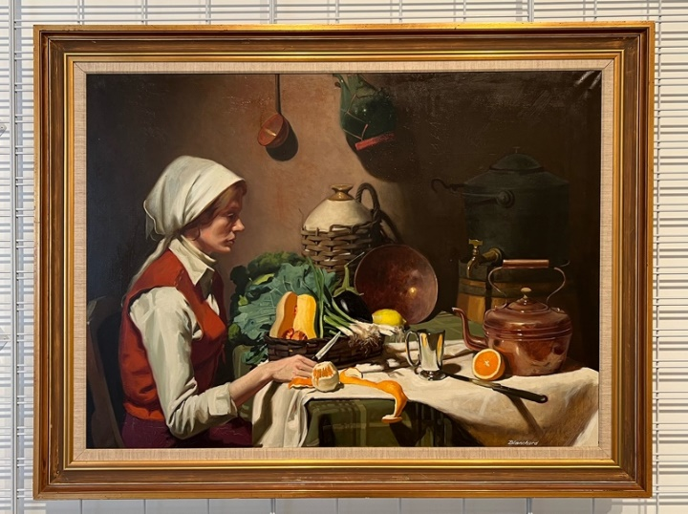

My family came and stayed while I painted and explored Rockhampton and the surrounding areas and that made the experience even more enjoyable for me. Thanks to the gallery staff for providing me with lists of things to do, especially for kids. My children also came into the gallery a few times and participated in the Children’s Holiday Program which they enjoyed immensely.

The residency provided me with valuable time to work and reflect on this project and my practice in general. The conversations and interactions I had with people were so useful and provided me with reflections and insights which were greatly appreciated in what is usually a very solitary practice.

Many thanks to Johnathan McBurnie and Helen Kavanagh for their time and care in making sure that I had a productive and fun time. The residency is one I will never forget, and I hope to come again one day ☺

