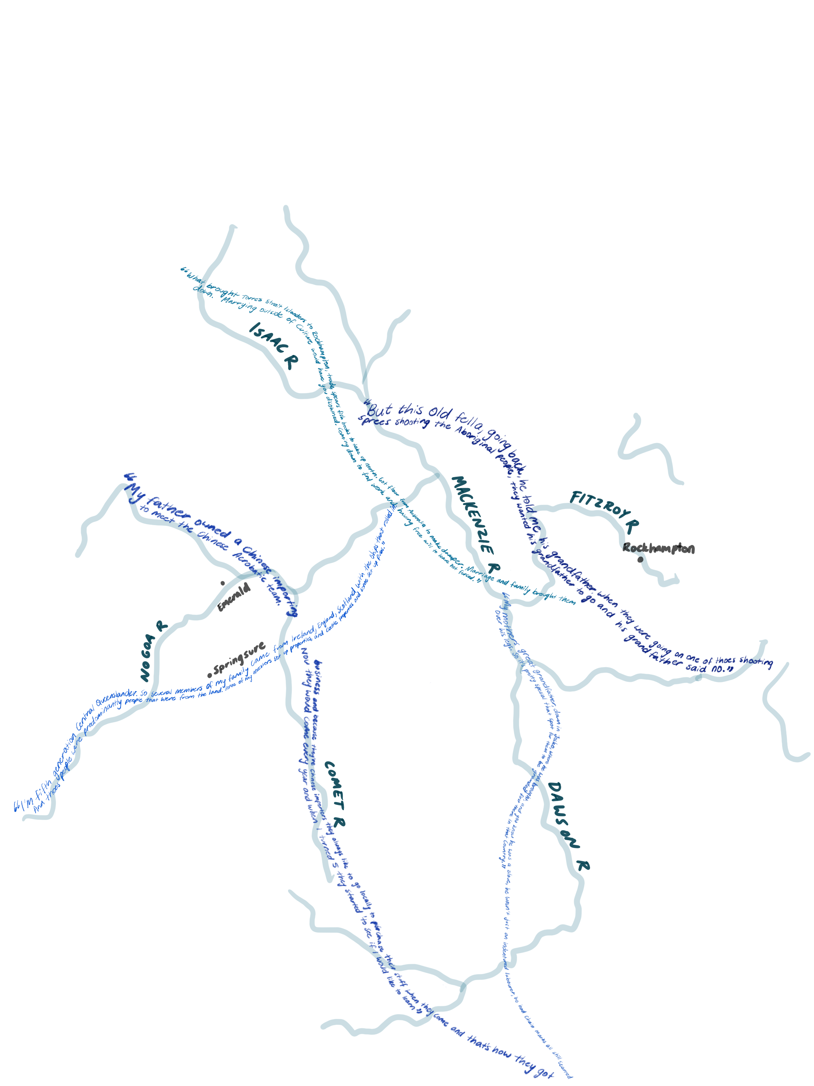This residency took place at the Rockhampton Museum of Art, built on Darumbal Country. Somewhere out near the Isaac sits Jack Kilgour’s Aboriginal Boy Drawing Totem - he knows about the five rivers and what they mean…The Comet River flows down dividing country near William Beavan’s Milparinga Stockyard, past Bevin’s Untitled Cattle Muster to join the Nagoa. The Mackenzie River rises and falls to tease Rupert Bunny’s Drought. Eventually it meets the Dawson river and comes down past Mabel Edmund’s On Jowalbina, down into Tunuba where Georgina McDonald’s Rowers in the Fitzroy River near the Lakes Creek Meatworks watch blood mingle with water. This body of water is traced by Charles Haywood’s Quay Street after the storm. Somewhere along Quay Street Estelle Petersen’s Customs House reminds us how much has

been lost and gained in the passing of time. Behind Quay Street waits Edith

Neish’s Stanley Street Railway Station whose metallic veins are no match for the ancient river systems. Stretched across Tunuba is Louis Le Breton’s depiction of the Fitzroy Bridge, watching the passing of water, passing of time, flow out past Lefevre Cranstone’s inked recollections of Ladies Beach, out towards the open ocean where David Jones’ Mabo Confronts Leviathan.

*Rockhampton Museum of Art* *1*

Margaret Olley Art Trust Collection Room Residency Artist in Residence Written Reflection

LeLarnie Hatfield & Joanna Joy 2025

What Australian television do you know that truly represents you or your community?

Sometimes an answer to that question can be hard to discover. Filtering through the Australian classics we all know and love like; The Castle, The Man from Snowy River, We of the Never Never, Kath and Kim, Picnic at Hanging Rock. Then thinking to later films and series like; Boy swallows universe, Bump, Territory and The Dry. How do these films reflect my experience as a regional Queenslander?

Research from Screen Australia’s Seeing Ourselves 2 highlights that regional areas and the stories of their communities are underrepresented in screen narratives. Home to 26% of on-screen characters compared to 33% of Australians, regional voices deserve greater representation.

Over the past 5 years Joanna has introduced LeLarnie to the world of film while LeLarnie has introduced to Joanna the heart of our Rockhampton Community. The Residency at Rockhampton Museum of Art has given us as creatives not only a physical space to work, be inspired and invite community in. It has also given us access to the historical records and artistic legacy of the Museum. All of this has been intrinsic to our filmmaking development of Generations of Men.

The residency deeply validated our filmmaking practice it gave us space to develop film in the way we wanted to do it, taking time to sit and listen to people and to Country. Developing our practice in a way that is Culturally safe and Community first.

We welcomed community to place their personal histories beside our chosen collection of artworks, adding to the depth of the visual stories of the new world we wish to build for our film. ‘World building’ is a term used within the film industry referring to the process of creating a detailed and immersive universe that supports the story, characters and themes of a film. Our world has expanded with deepened roots connecting us to Character profiles, trickles of streams leading us to potential film locations, branches with leaves that blow memories in the wind of historical events, spread across a night sky is the burning stars of visual content of country and the birds sing and squark of dialog from that time period.

During our time interviewing community and exploring the Museum artworks and Library collection we identified recurring themes that resonated with and validated our previous development adapting Judith Wright’s works, her poems and books *Generations of Me*n and *Cry of the dead*.

The supported autonomy we had throughout our residency was overwhelming allowing us to workshop with students, host movie screenings and invite community voices to the space, not as guests but as guides.

On the final day we held an open reflection space called *‘Stories along the five Rivers’*, a moment of appreciation, shared breath, shared meal, shared ideas and deep listening with those who had been along the journey with us. Everyone who entered felt seen, safe and heard. The space was more than closure, it was ceremony. A return to the source because like the five rivers that flow into Tunuba through Central Queensland, our workflows from connection. This residency didn’t just support our practice it mirrored the way we move through our world. With care, kinship, and with an understanding that story lives in water, in people, in place and that all of it flows together.

We’d like to extend our heartfelt thanks to Rockhampton Regional Council, Haymans Electrical and to the deadly team at the Rockhampton Museum of Art for going above and beyond during our residency. You created such a welcoming, supportive space that allowed our practice to grow in the most meaningful ways.

I’d like to extend a big, heartfelt thank you to our community for participating in our workshops, artist talks, film screenings, and interviews. The stories you shared brought so much life and inspiration to our work. Some of the interview quotes can be seen above on page one—a powerful collection of stories from five of our interviewees. These are stories along the five rivers, representing Darumbal, Chinese, Torres Strait Islander, South Sea Islander, and non-Indigenous family histories.

To the install team, thank you for your care and attention in bringing our work to life in the gallery.

A special thank you to Tessa for her thoughtful curation. Her selections from the Museum Collection beautifully echoed our adaptation materials. We’re especially grateful for the opportunity to view works kept in storage, pieces with powerful stories that we were honoured to spend time with.

To Easton, Helen, and Aunty Melinda, thank you for guiding us, for making us feel part of the team, and for all the behind-the-scenes work that made everything flow so seamlessly. Your support and excitement for our project meant the world to us.

To the beautiful front-of-house staff and all staff within the building your smiles, your warmth, your assistance on weekends and your presence and participation in our talks made Rockhampton Museum of Art feel like home.

To any artist considering applying for this residency: you’ll be in the best hands. The Rockhampton Museum of Art team walks with you every step of the way. We are very thankful for the time we spent in this space manifesting and creating our world plus developing creative materials. We have walked away from this Residency feeling more grounded, confident and ready for the next steps within our film development. For us, this experience truly validated that the work we do in film is recognised as a form of art. We couldn’t have been prouder to bring the silver screen to the Rockhampton Museum of Art for the first time as part of the Artist in Residence program.