Margaret Olley Art Trust Collection Room Residency

Artist in Residence Written Reflection

Louise Lawrence

2025

My Margaret Olley Collection Room works were chosen on the basis of their connection to CQ, earthy colour scheme and/or depiction of landscape. My intention was to research each one and respond to it. However these six formed the basis of my exploration.

- Pamela Croft
- Fred Williams
- Kim van Nguyen
- Patrick Connor
- Carmel Knowles
- Peter Annand

I went into this AIR with no goals or expectations apart from the desire to use wild clay and explore gelli printing. I wanted to simply respond to the chosen artworks organically. After researching the first three artists: Patrick Connor, Fred Williams and Pamela Croft I drew brainstorming diagrams of key ideas and themes along with sketches of proposed works. Fred Williams has always been a favourite artist of mine; his capturing of the Australian landscape with almost abstract shapes, high horizon line and space is iconic. I set myself a challenge to transform aspects of the local central QLD landscape into 3D form ie using ceramics. The gourd shaped apricot clay work features carved motifs that echo Williams’ depiction of trees. Patrick Connor’s work ‘Explosive Landscape ‘ was the catalyst for many conversations with those who dropped into the studio; the uneasy beauty and surrealistic nature of his colour and mood highlighted my own tension with minescapes as aesthetically beautiful but intrinsically destructive to the environment. My own response to depicting an open cut minescape was using a gourd shape and carving into marbled clay . Pamela Croft’s work ‘transgressing cultural boundaries’ was interesting to research; I learnt a new philosophy and methodology around indigenous artworks titled ‘bothways’ in which both the western and indigenous framework are equally represented in art. Her use of ochre and rhythmic lines illustrated for me the power of simplicity of form to communicate meaning in the audience.

Main Works

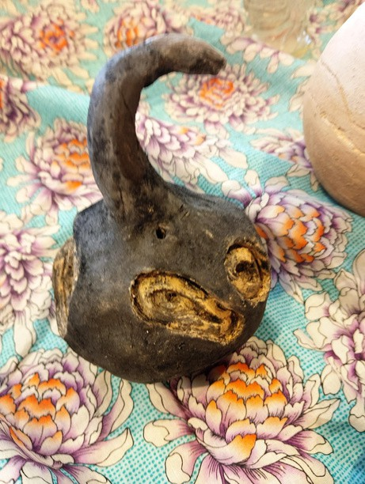
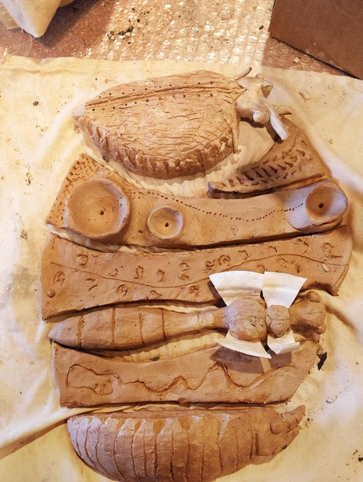

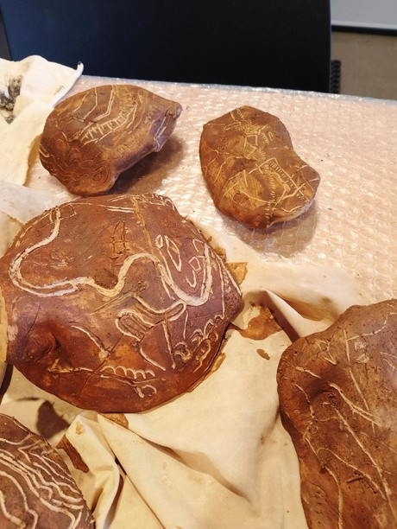
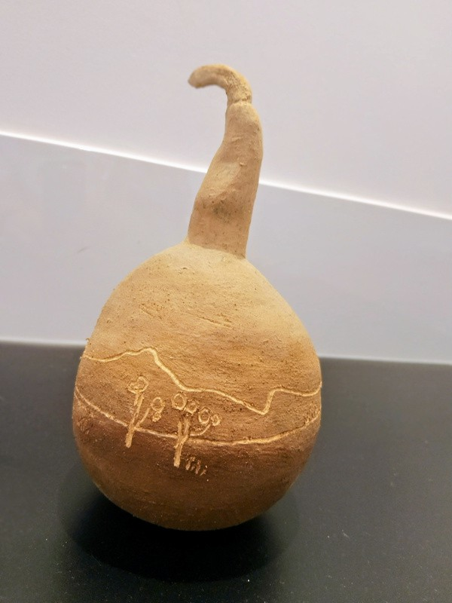
Main Works
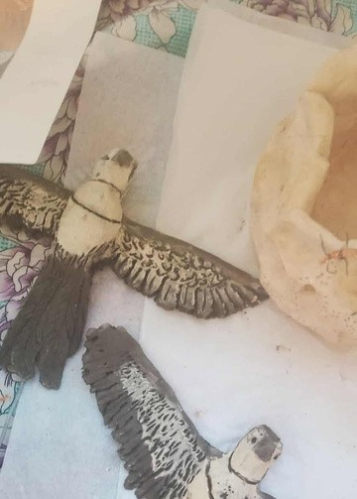
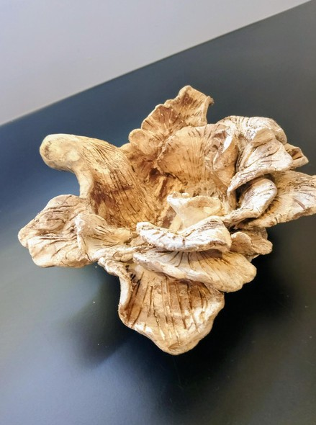
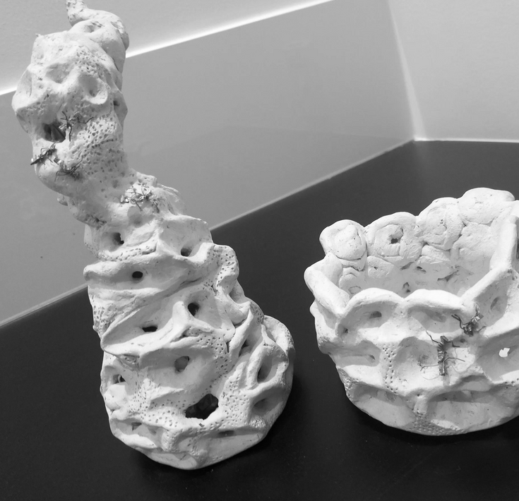
Trails- A Landscape
Peter Annand’s Photograph ‘Antlions’ was helpful in directing my efforts to depict landscape in clay; an antlion landscape mirrors marks we as human make on the earth. My investigation into antlion behaviour resulted in my antlion nest vase and bowl made using newly discovered apricot kaolin clay dug from Baree. The clay lent itself well to shaping an open coil form to mimic the traps created by antlions to catch ants and I shaped copper and wire into ants to sit on the trail. As a secondary response I created individual tiles of clay each depicting different trails and the antlion larvae which together would form a pictorial landscape.

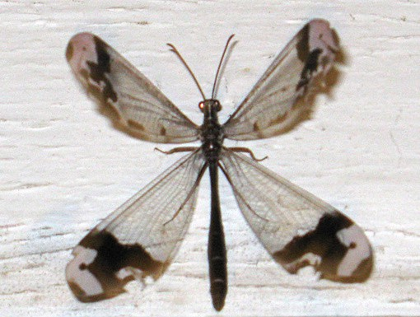
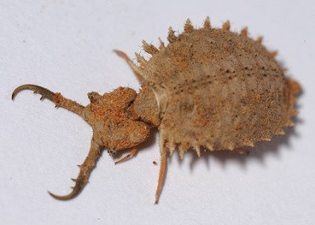
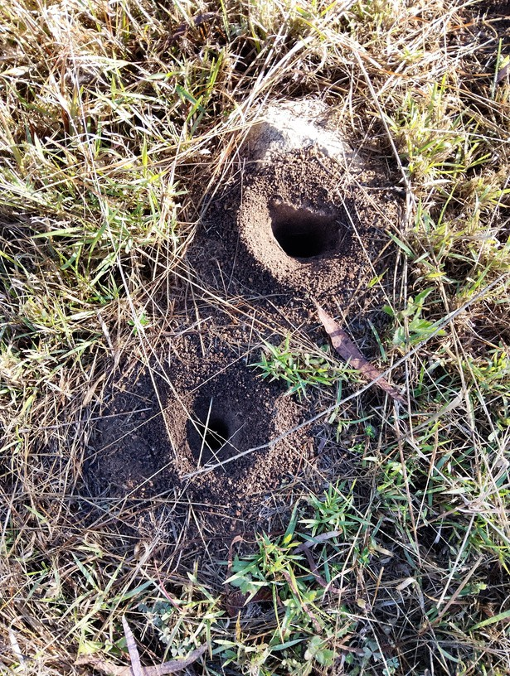

Local Snapshots
Everyday I walk the trails around No.7 Dam and observe nature. Some of my snapshots I printed out for the studio wall.

These fungi are located on heritage listed trees in Yeppoon. Inspired by the ochre and white simplicity of Pamela Croft’s work, I experimented with layering black and white clay so that once rolled I used cardboard moulds to form mushroom shapes. Unfortunately the black clay was untested and when air dried began to flake and collapse. I replicated the process using black and pale apricot clay with the same result.

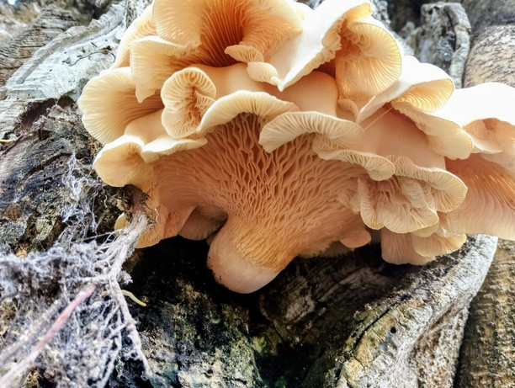
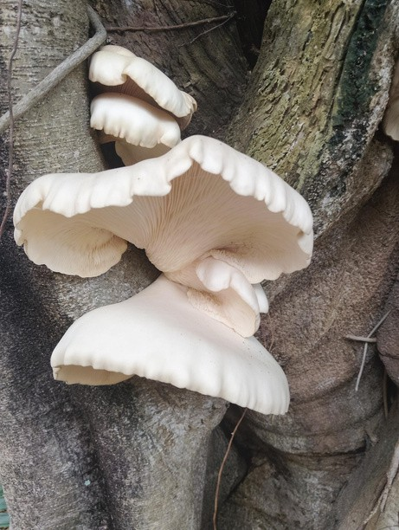
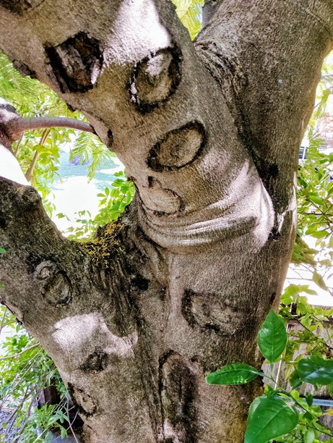
Trial and Error
What I enjoy about using wild clay is the unpredictability and surprising characteristics of each coloured clay. When this stripy layered effect did not work I found a combination of pale apricot and terracotta clays which was robust enough to form intricate curves of the funghi. The pale clay was used alone to create the series of white mushrooms but decorated with slip and sgraffito technique used to carve topographic and parish maps onto the top. In this way the layers of landscape are reproduced to become a map of sorts within the funghi form.

The same trial and error process was necessary when exploring gelliprinting. I had great success utilising leaves and flowers in complementary colours. But when attempting to transfer sepia photographs of historical mine scenes both modge podge and gloss medium did not work. I tried to use monoprinting techniques of cutting out card and removing areas of paint while using different materials to imprint texture.
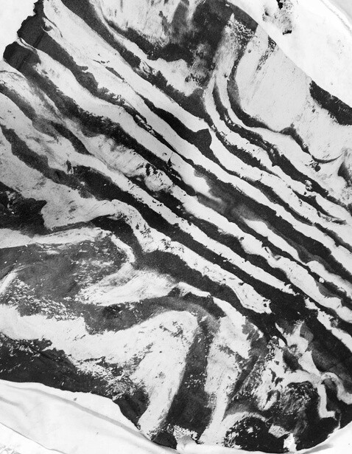
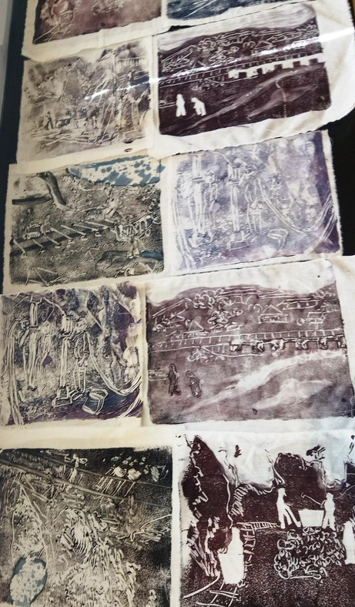
Paper Clay
The discovery of paper clay was a highlight of the AIR. Not only was ‘Spinifex’ created using paper clay, but the medium is very well suited to use of wild clay. The black clay that did not hold up under firing was perfect when blended with 50% recycled paper/banana tree pulp. The resulting finches created with this recipe turned out very robust and detailed. I am very excited about the future possibilities with this medium.

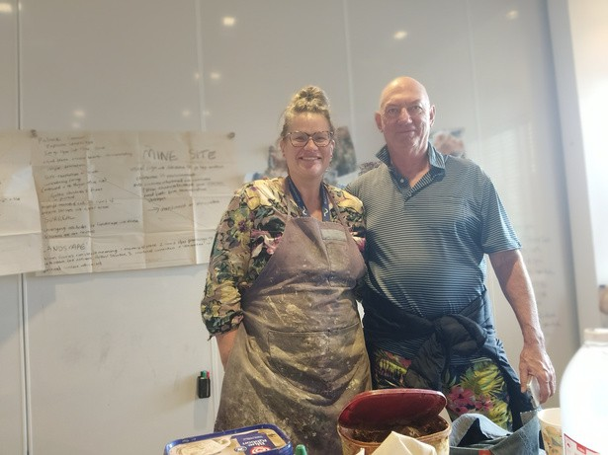
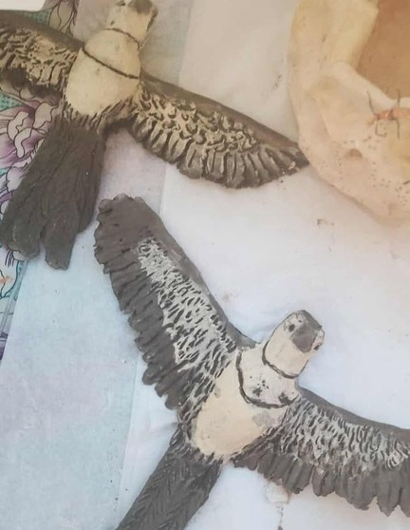

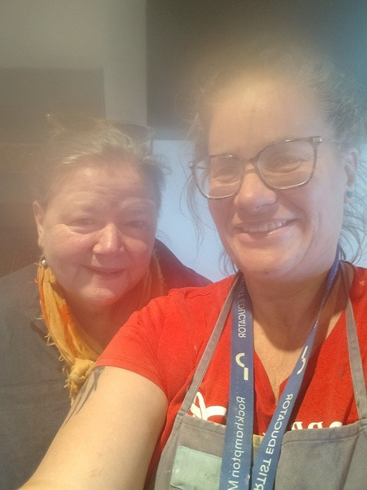

Experiences

Storytelling is an essential part of my art practice; being able to share my story and journey in art and hear that of others was a special part of AIR. Two artists whose works were in the Margaret Olley collection shared time and insights with me during this month. Carmel Knowles with ‘indelible’ came to hear my artist talk; it was exciting to discover she shared many of my ethics and processes in terms of sustainability and arts practice. I reached out also to Patrick Connor of ‘explosive landscape’ and enjoyed a lively discussion about planetary landscapes and environmental destruction. The spontaneous visit by Auguste Blackman was especially memorable as I am a huge fan of his father. To listen to anecdotes of Charle’s life and art was a treat.

Future Exhibitions
The residency at RMOA was a catalyst for three upcoming exhibitions in the works.
Scheduled for February is ‘Trails: a landscape‘ which will show my antlion and fungi ceramic works locally.
The gelliprint on fabric historical photos will form part of ‘Haunts: the historical hotels of Mount Morgan’ due to be displayed at Goldenmount Festival 2026. The birds will be part of a 2027 joint exhibition with fellow artist Pauline Grabham

Reflections
The Artist in Residency at RMOA 2026 was without a doubt the most important and significant event in the history of my art practice. Not only was I given a huge amount of support and inspiration in the Gallery and program room, I was surrounded by artworks and collections to daily push me forward to explore, discover and create. The interaction with staff and visitors, school groups and fellow artists allowed formative discussions around future art direction and helpful feedback about avenues to explore. To have a physical space and the ‘mind’ space to
simply reflect and respond to the collection is a luxury I don’t ever have in my life as a mother and artist; it was an amazing privilege and I cannot overstate the impact it has had and continues to have on my arts practice
